**Transcript**

|  |  |  |
| --- | --- | --- |
| **Question** | **Answer** | **Translate** |
| 1. Can you please introduce yourself, sir/ma’am? | Ako si Jemmel Maurat may ari ng CMDP Garage Motorshop located dito sa Navotas. | I am Jemmel Maurat owner of CMP Garage Motorshop located here in Navotas. |
| 2. Can you describe your business? | Motorcycle shop pero ang una talaga naming negosyo is yung sa ilaw, mga distributor kami ng ilaw etong mga LED, sa mga highrise building, before pandemic, nakapag patayo kami ng motorcycle shop which is, eto kase ang gusto ng asawa ko, mahilig kase sya sa motor, | Motorcycle shop, but our first business is that of lighting. We are distributors of LED lights in Highrise buildings. Before the pandemic, we were able to set up a motorcycle shop, which is what my husband likes because he loves it on the motorcycle. |
| 2.1. But you have another branch? | Nagkaron kami ng branch pero pinasarado din namin kase nagkaroon ng conflict doon sa lumapit sakin na gustong makipag partnership kase pinasarado din namin kase nagkaron ng problema. | We opened a branch, but we also closed it because there was a conflict with someone who approached me who wanted to partner, so we also closed it because there was a problem. |
| 3. What is the problem of your business and how the impact of it? | Actually madaling magtayo ng negosyo, but the problem is pag wala kang tao na pagkakatiwalaan lalo, kasi kami dito, nung una talagang hands on kami, kailangan namin sumabay sa tao namin, from 9pm to 4am, 3am tulog saglit, then tuloy sa trabaho. Mahirap makahanap ng trabahador na mapagkakatiwalaan mo sa lahat, kase before nagkaroon ang mga employee na nagka-inggitan sa kapwa nila employee, sempre pag ganon nagkakaroon ng away at naapapektuhan yung business, may mga naging pasaway rin akong trabahador kaya mahirap makakuha ng pagkakatiwalaan. At sempre pag hindi nakikita ng client yung potensyal ng negosyo mo hindi nila bibilhin. | Actually, it's easy to build a business, but the problem is when you don't have someone to trust, especially because here, when we first were really hands-on, we had to go with our people from 9 p.m. to 4 a.m., sleep for a while at 3 a.m., then go to work. It's hard to find a worker that you can trust with everyone, because before there were employees who were jealous of their fellow employees. So when there was a fight and the business was affected, I also had some workers who were reprimanded, so it was difficult to get trust. And if the client doesn't see the potential of your business, they won't buy it. |
| 4. What is the current system that your business has? | Current sistema sa aming negosyo? Commission Basis System, kaya naman naisip ko ang commission basis system kaysa magbayad ng limang daan (500) o anim na raan (600) kada araw bilang mekaniko, mas maganda ito dahil commission basis ito, dahil kung hindi ka magtatrabaho, hindi ka babayaran, to be exact No Work, No pay. pero bilang marketing people ako, same time the owner itself, the owner of bussiness, di ko hahayaan na sa isang araw na or sa isang cycle ng operation naman na mawalan talaga ng kita. | Current system in our business? Commission Basis System, that's why I thought of the commission basis system rather than paying five hundred (500) or six hundred (600) per day as a mechanic, it's better because it's a commission basis, because if you don't work, you don't get paid, to be exact No Work, No pay. but as a marketing person, at the same time the owner himself, the owner of bussiness, I will not let a day or a cycle of operation to really lose income. |
| 4.1. So manually? Like, for example, someone ordered you to collect it manually? | Oo manual kami, manual basis, yung nakalista sa log-book | Yes, we are on a manual basis, the one listed in the log book. |
| 4.2. How do you do inventory? | May inventory din kami, may ginagawa din na inventory system kami, actually monthly yon, on every 15 days. | We also have an inventory; we are also working on an inventory system; actually, it's monthly, every 15 days. |
| 4.3. What about the log book? Is it just a manual inventory like a log book, just writing items, or is it computerized? | Manual lang kame, pero itatransfer ko sya through excel lang, tapos don nalang ako nag pa-plus minus, inventory ko this month, total inventory ko last month, projection chart, gumagawa kami non, para atleast alam ko kung ano yung mga item ko na nabenta ko ngayong buwan, ano nabenta last month, same time gumagawa din ako ng graph, ng percentage, saan ba mas malakas, ano ba yung mas malakas ngayon, yung labor, at yung benta, kase kailangan usually sakin kailangan yung labor mo nag co-conduct lang sya dyan sa benta sa since lang sya tsaka slightly 15 % lang | It's only manual, but I'll transfer it through Excel, then I'll do plus and minus, my inventory this month, my total inventory last month, projection chart, we're working on it, so at least I know what my items are that I sold this month, what was sold last month, and at the same time I also make a graph, a percentage, which is stronger, what is stronger now, the labour, and the sales, because I usually need your labour. He only co-conducted the sales there since he was only slightly 15% |
| 4.4. Aren't you having a hard time recording it manually? | Di ehh, traditional traditional, sa tagal na namin nag nenegosyo kumbaga lahat ng nakikita nyo sa shop namin fast moving yan, di yan tatagal ng tatlong buwan (3 months), kaya mabilis syang malalaman kung kulang ba, lahat yan as in fast moving yan kumbaga meron nabebenta sa isang buwan (1 month), kaso yon nga yung ano namin, laging ubos in a week, bibili ka ng bulb, ubos. | No, it's traditional. For the time we've been doing business, it seems that everything you see in our shop is fast moving; it won't last three months (3 months), so it will be quickly known if there is a shortage. Everything is fast moving. It seems that something is sold in one month (1 month); that's the case with us; it always runs out in a week. If you buy a bulb, it runs out. |
| 5. What is the advantage of your current system? | Meron, kase di naman kami magpapasahod pag wala talagang benta sa isang araw. | There is, because we don't pay wages if there are no sales in one day. |
| 6. What is the disadvantages of your current system? | Disadvantage siguro yung mawawalan ng sahod yung mga tauhan namin dahil sa walang kita sa isang araw. | The disadvantage might be that our staff will lose their wages due to no income in one day. |
| 7. Who are the primary users of the system, and what are their roles? | Kaming dalawa lang ng asawa ko na owner ang naghahandle. | My husband and I, the owner, are the only ones handling it. |
| 8. For you, what kind of system should we do to solve your stated problem? | Gusto sana naming is yung P.O.S na may scanner, although magastos pero may printer naman kami at kayang mag provide para sa barcode na igegenerate, gusto ko POS na connected yung Inventory System para matrack namin yung sales na meron kami in real-time. | We would like a P.O.S. with a scanner; although it is expensive, we have a printer and can provide for the barcode to be generated. I also want a POS connected to the inventory system so that we can track the sales we have in real-time. |
| 9.Can you walk us through the processes that the system will be developing? | Oo, Pwede naman. | Yes, it’s you can. |
| 10.Do you have any recommendations or suggestions for the system we will be developing | Tsaka na lang siguro pag nakita na naming yung system na gagawin ninyo, para madagdagan or mabawasan namin. | Maybe only then when we see the system you are going to make, so we can increase or decrease it. |

**BUSINESS ESTABLISHMENT**

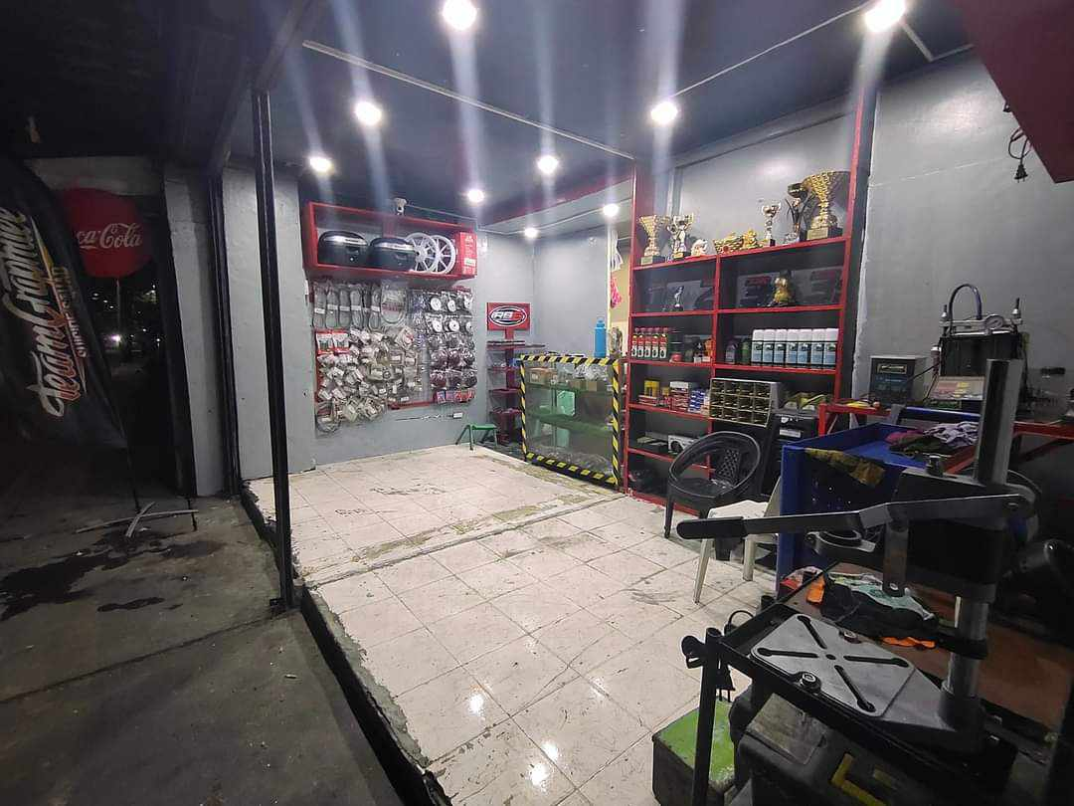

CMP garage is a motorcycle shop, that retail store with a focus on selling, servicing, maintaining, customizing motorbikes carried out by skilled technicians with extensive experience in motorcycle maintenance, and associated equipment. Motorcycle shop enterprises are integral to the active community of motorcycle followers, since they prioritize providing excellent customer service and have a full support for all things motorcycle-related.

